Installation and Configuration of I-doit

System Requirnments :
Virtual hardware
- 2 vCPUs
- 2 GB RAM
- 10 GB free hard disk space
OS : Ubuntu 14.04 LTS
Installation steps :
sudo apt update
sudo apt install apache2 libapache2-mod-php5 php5 php5-cli php5-common php5-curl php5-gd php5-json php5-ldap php5-mcrypt php5-mysqlnd php5-pgsql unzip
sudo apt install mysql-server-5.6 mysql-client-5.6
mysql –version
sudo php5enmod mcrypt && sudo service apache2 restart

settings :

It is recommended by the packets different settings to be recorded in separate files rather than adapt the existing configuration files.Each package upgrade differences in the settings would be faulted or overwritten.By separating arise double entries that match Apache / PHP / MySQL, however, without problems, so that the default values of the distribution will be overwritten by the user.
1.PHP
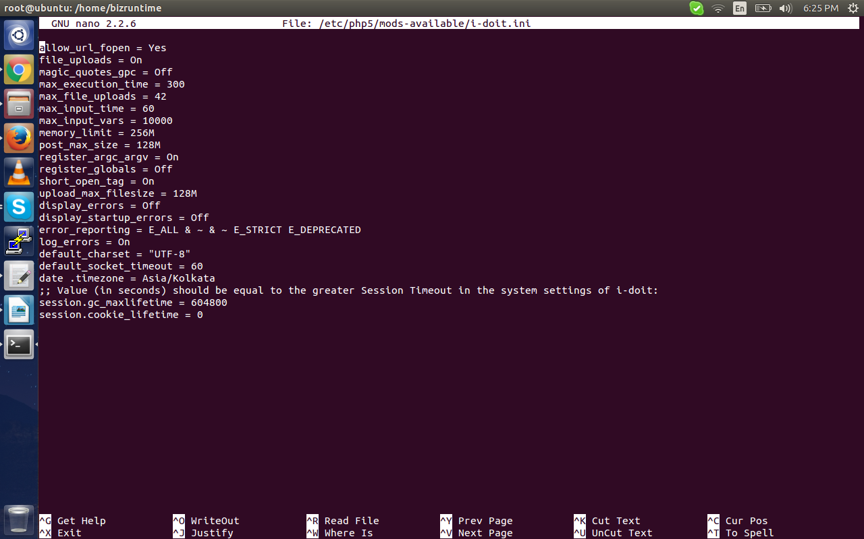
sudo nano /etc/php5/mods-available/i-doit.ini
The parameter date.timezone should adapt to the local time zone.
sudo php5enmod i-doit
sudo service apache2 restart
The session management of PHP often caused problems among more senior versions of Debian / Ubuntu. The package php5depends a cron job under/etc/cron.d/php5 a who too often deletes valid sessions. If the directory/etc/php5/conf.d/exists, creates a symlink to the above PHP settings Remedy:
sudo ln -s /etc/php5/mods-available/i-doit.ini/etc/php5/conf.d/
sudo apt update
sudo apt install php5-memcache memcached
sudo php5enmod memcache
sudo service apache2 restart

sudo apt update
sudo apt install php5-APCU

sudo apt update
sudo apt install php5-xcache
sudo php5enmod xcache
sudo service apache2 restart

(At recommended settings Debian-based operating systems under /etc/php5/mods-available/xcache.ini to find):

check below entrys in /etc/php5/mods-available/xcache.ini file

xcache.shm_scheme ="mmap"
xcache.size = 64M
xcache.count= 1 # Number of CPU cores
xcache.slots = 16K # Depending on the memory
xcache.var_size = 128M
xcache.test = Off
xcache.optimizer = On
xcache.cacher = On
xcache.stat = On

save and exit from file.

sudo service apache2 restart

2. APACHE2

Now , open /etc/apache2/sites-available/000-default.conf
make new entrys in the bottom of the file.

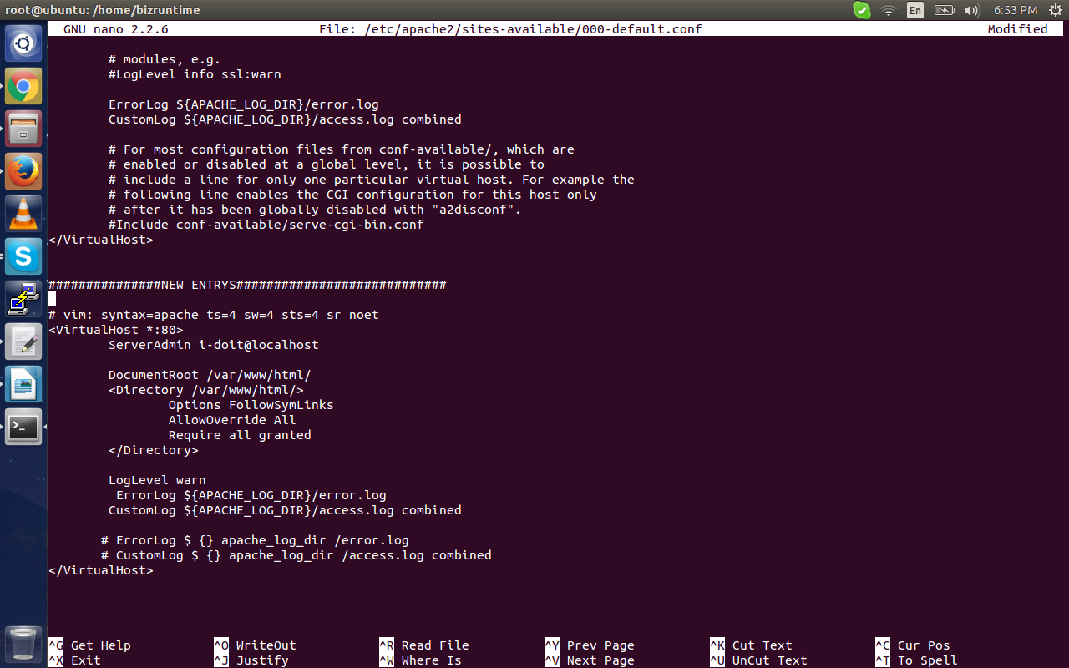

Save and exit.
Run following command to reload configuration.
sudo service apache2 reload.

Create i-doit.conf and paste new entrys from /etc/apache2/sites-available/000-default.conf
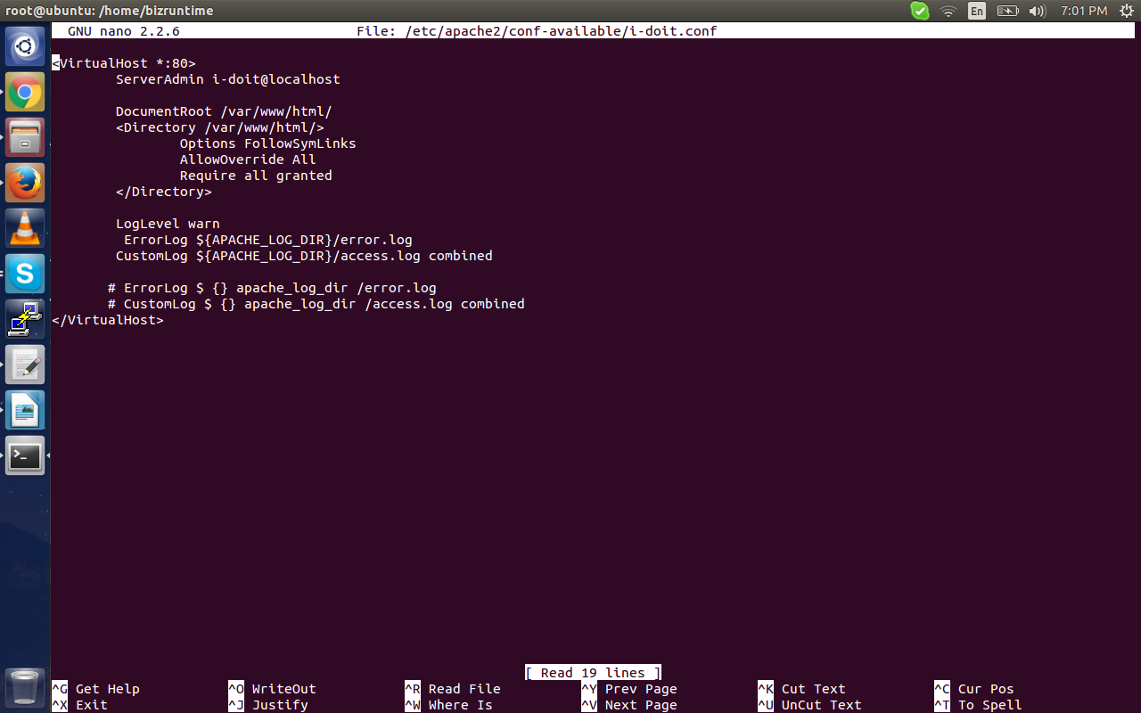
sudo nano/etc/apache2/conf-available/i-doit.conf

sudo a2enconf i-doit
sudo a2enmod rewrite
sudo service apache2 restart

3. MYSQL

When configuring MySQL / MariaDB is very important to ensure on which (virtual) hardware equipment, the i-doit installation is based. Depending on how much RAM, how many CPU cores and what storage is available, different information must be provided:

In this installation we have 2GB RAM and 2CPU cores
copy below lines and paste to /etc/mysql/conf.d/i-doit.cnf
sudo nano /etc/mysql/conf.d/i-doit.cnf

[Mysqld]

# This is the number 1 setting to look at for any performance optimization
# It is where the data and indexes are cached: having it as large as possible will
# Ensure MySQL uses memory and not disks for most read operations.
#
# Typical values are 1G (1-2GB), 5-6g (8GB RAM), 20-25g (32GB RAM), 100-120G (128GB RAM).
innodb_buffer_pool_size = 1G
innodb_buffer_pool_instances = 1 #use multiple instances if you have
# Innodb_buffer_pool_size> 10G, 1 every 4GB

# Redo log file size, the higher the better.
# MySQL writes two of synthesis log files in a default installation.
innodb_log_file_size = 512M

innodb_sort_buffer_size = 64M
sort_buffer_size = 262144 #default
join_buffer_size = 262144 #default

max_allowed_packet = 128M
max_heap_table_size = 16M
query_cache_min_res_unit = 4096
query_cache_type = 1
query_cache_limit = 5M
query_cache_size = 80M

#tmp_table_size = 32M
table_cache = 256
max_connections = 200
innodb_file_per_table = 1

# Disable this if you have only one to two CPU cores (= 0), change it to 4 for a quad core.
innodb_thread_concurrency = 0

# Disable this if you have slow harddisks (= 0)
innodb_flush_log_at_trx_commit = 1
innodb_flush_method = O_DIRECT

innodb_lru_scan_depth = 2048
table_definition_cache = 1024
table_open_cache = 2048
#table_open_cache_instances = 4 # Only if your have MySQL 5.6 or higher, do not use with MariaDB!
sql-mode =""

save and exit.

sudo service mysql restart

4. I-doit Setup

To download I-doit source code , you have to do registration on website http://www.i-doit.org/download-2/

sudo mkdir /var/www/html/ i-doit
sudo cp /path/to/i-doit.zip /var/www/html/i-doit/
cd /var/www/html/i-doit/
unzip i-doit.zip
rm i-doit.zip

cd /var/www/html/i-doit/
sudo chown www-data:www-data -R .
sudo find . -type d -name \* -exec chmod 775 {} \;
sudo find . -type f -exec chmod 664 {} \;
sudo chmod 774 controller tenants import updatecheck *.sh

5.Web GUI
The setup is called automatically when the browser i-doit calls (eg http://yourhostIp/i-doit/).

system check
In the first step important system settings are queried. If anything should be fine, the user is alerted.
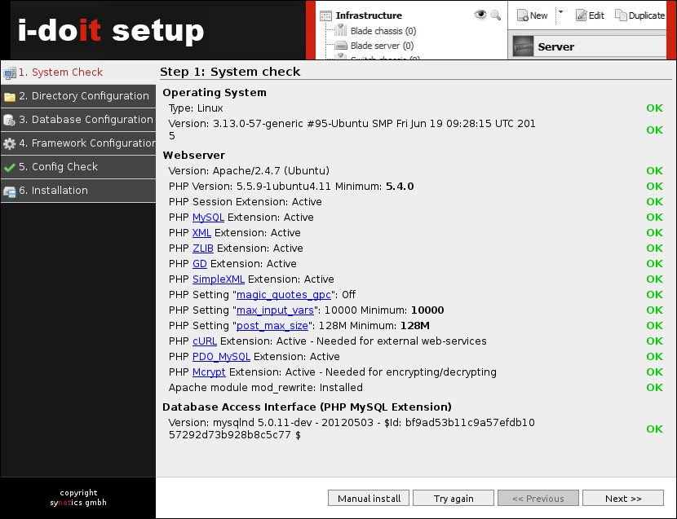

Directory Configuration
Here, the paths are requested, are to be stored in the installation and user files.The proposals can be adopted.
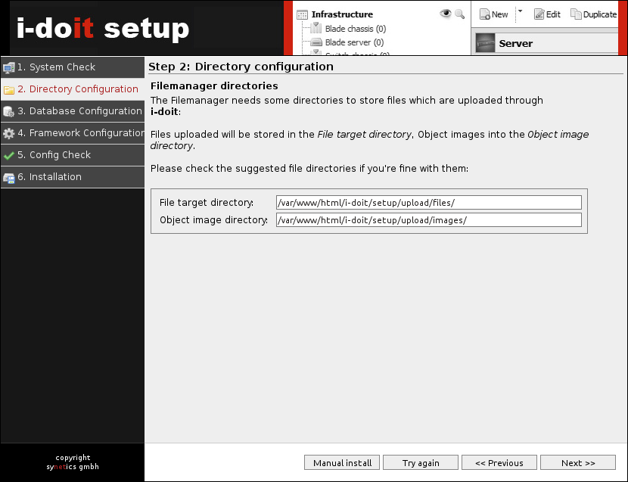

Database Configuration
For the database connection credentials and important settings are entered.For i-doit least two databases and a specific user can be created.
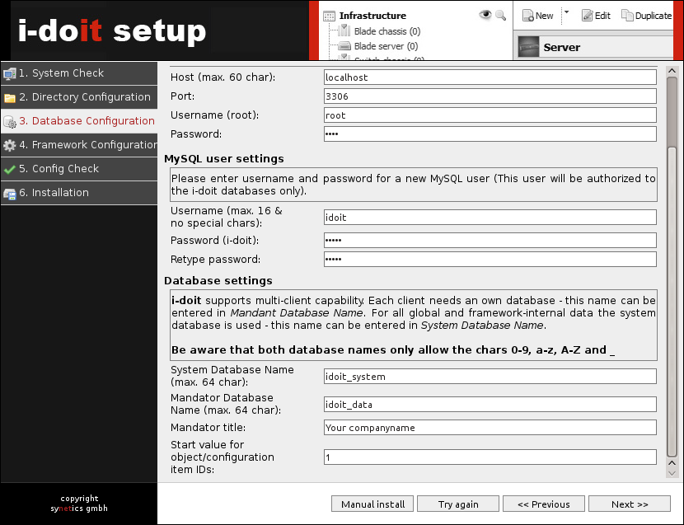

Connection settings
  - Host:usually the host itself, so localhost
  - Port: usually the default port of MySQL , ie 3306
  - Username:Username of database system user, usuallyroot
  - Password: password of the user
- MySQL usersettings
  - User Name: User name of the owner of i-doit databases, mostly idoit
  - Password: password of the user
- Database settings
  - System Database Name:Name of the system database, mostly idoit_system
  - Mandator Database Name: Name of the database for the first clients, mostly idoit_data
  - Mandator title: Title of the clients, usually the name of the organization that is the focus
  - Start value for object / configuration item Ids: usually 1

Framework Configuration
To access the Admin Center in i-doit there are separate credentials that can be set here. It is recommended to do so.
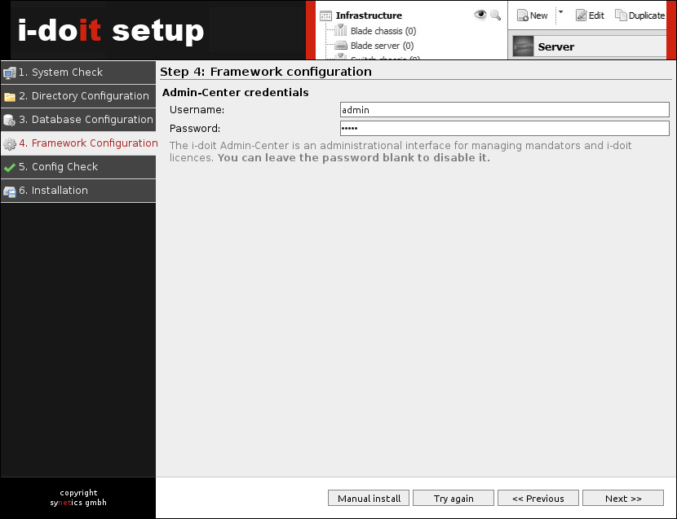

Config check
In this step, all previous steps are combined and checked if the setup can be completed.

import license
A subscription license you can either through the Admin Center or Administration → License Management import.

